Instructions on How to Deploy a SAS Job:

1. Make sure that the SAS & JCL files are set up so that they can be run properly. Check to see if Github houses a local-run-ready copy of the code. Check to see if the developer needs to comment out local system functions & macros, such as “%SYSLPUT”. Reach out to them if they do. If no updates are needed and the copy is local-run-ready, skip to **Step #2**. If the copy is set up for a remote run rather than a local run, reach out to the developer to comment out/alter the appropriate lines of code. This will usually require them to comment out certain lines of the code, such as:

Comment out the following lines:

* Report output location needs to be changed from T:\SAS to “%SYSGET(reportdir);”
* LIBNAME statements declared before RSUBMIT;
* RSUBMIT statement itself;
* ENDRSUBMIT statement;
* Any datasets that are copying from the remote server (i.e. “DATA final; SET LEGEND.final; RUN;”). (*Note*: This code pulls the data set from the remote server to a local copy, which does not need to be done in the test run. Furthermore, there might be several spots in the code where data sets are being returned, so this might require the developer to comment out multiple sections of code by using the “/*” and “*/” comment characters.)

1. Put the JCL and SAS files in the test folder location
   1. This can be done by clicking on the button highlighted in **Figure 2.i** and then clicking on the “Find Files” button (see **Figure 2.ii**). After navigating to the spot that the prepped files are saved, move them by clicking and dragging them into their appropriate spots (the SAS file goes into the “Drop SAS files here” box, and the JCL file goes into the “Drop JCL files here” box).
   2. Hit the “Next >>” button.

**2.i**

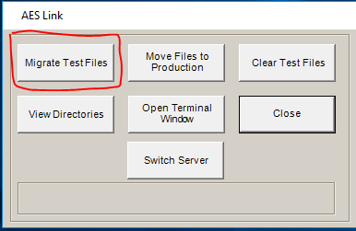

**2.ii**

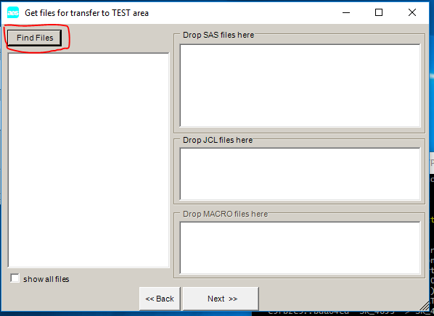

1. Click on the View Directories button (see **Figure 3.i**) and then select the “Test Job Scripts (*.JCL)” option in the dropdown menu (see **Figure 3.ii**). Next, select the job and click the “Run Test JCL” button after verifying that the proper database is being hit. Usually you will want to target Prod and not Test (e.g. VUK1/VUK3 instead of Legend, QADBD004 instead of Duster), so change the server as needed.

**3.i**

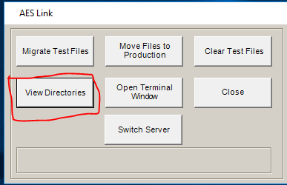

**3.ii**

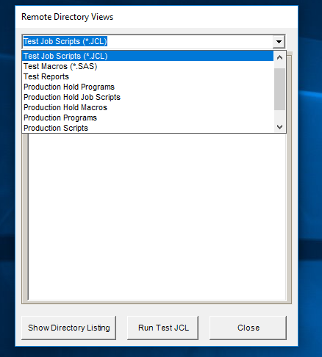

1. The job is now running. You should verify that it takes the expected amount of time to run, and then verify that the output looks good. In order to do the latter, you can click on the View Directories button (see **Figure 3.i**) and then select the “Test Reports” option from the dropdown menu. Once the job is finished running, you should see each of the expected R-files in the window. Clicking on the R1 file allows you to look over their logs to see the output. (Clicking on the other files allows you to see the data output of them.) Examine the output for any mentions of “ERROR:” to verify that no actual errors occurred. Additionally, look for “WARNING” and “TRUNCAT”; if you are getting either of these, then think about optimizing the code to circumvent these issues. If not all R-files appeared, check the code to see why this occurred.
2. Additionally, when examining the SAS log, keep your eyes open to odd informational notes that could have a big impact on performance. Common ones include issues with re-merging summary statistics back into the original query dataset[1] as well as issues stemming from SAS trying to interpret != or <> as ^= (SAS not equals).
3. If the output looks good, and everything is ready for promotion, clean up your output. If you generated reports on the remote server, delete them.
4. After verifying the output looks good, place the job in the appropriate BA’s court for promotion. They will then move the files to AES’ staging area for Production.

1. Often caused by having an incomplete group-by statement.